Functional Requirements
1. Customer Management
- Register new customers.
- View and update customer details.
- Delete customer records.
- Search customers by name, city, phone number, or email.

2. Product Management
- Add, update, view, and delete products.
- Search products by product ID or name.
- Filter products by name, price, price range, and company.
- View product details and available stock.

3. Customer Login
- Allow customers to register and log in.
- Allow customers to log out securely.
- Restrict shopping and ordering to logged-in customers.

4. Shopping Cart
- Add products to the cart.
- Update product quantities.
- Remove products from the cart.
- View cart items and total amount.
- Check product availability before checkout.

5. Order Management
- Place orders after customer confirmation.
- Store and retrieve customer orders.
- Calculate product subtotal, shipping cost, discounts, and final amount.
- Update order status.
- View order history and tracking details.

6. Payment Management
- Support UPI payments.
- Support debit and credit card payments.
- Support Cash on Delivery (COD).
- Support gift card payments.

7. Order Tracking
- Track dispatched orders.
- Display courier and transit status.
- Update orders as delivered or returned.

8. Subscription Management
- Provide monthly, quarterly, half-yearly, and yearly subscriptions.
- Offer free shipping to active subscribers.

9. Discount Management
- Provide discount coupons based on qualifying order history.
- Check coupon eligibility.
- Apply eligible discounts to orders.

The OOP concepts demonstrated are
1. Encapsulation and data hiding
Example: Customer, Product, CartItem, and Order.
- Keep fields private.
- Validate updates through public methods or constructors.
- Don't expose a mutable internal collection directly.
- Don't let callers set an arbitrary order status without checking the transition.
public class CartItem {
private final Product product;
private int quantity;
public CartItem(Product product,int quantity) {
if(product==null||quantity<=0) {
throw new IllegalArgumentException("Invalid cart item");
}
this.product=product;
this.quantity=quantity;
}

public void changeQuantity(int quantity) {
if(quantity<=0) {
throw new IllegalArgumentException("Quantity must be positive");
}
this.quantity=quantity;
}

public int getQuantity() {
return quantity;
}
}

2. Abstraction
Example: PaymentMethod and ShippingPolicy.
A checkout service should request a payment without needing to know the internal details of every payment type.
public interface PaymentMethod {
PaymentResult pay(BigDecimal amount);
}
CheckoutService depends on this contract, not on the internal implementation of UPI, cards, COD, or gift cards.

3. Inheritance
Example: customer account types or payment types.
We could create an abstract CustomerAccount with common account behavior, then derive RegularCustomerAccount and SubscribedCustomerAccount.
A subscription is often better represented as a separate Subscription object associated with a Customer, because it has its own plan, expiry, and lifecycle.
Payment implementations are a natural place to demonstrate inheritance through an abstract payment class, with an interface defining the contract.

4. Polymorphism
Example: one checkout workflow supporting multiple payment methods.
PaymentMethod paymentMethod = new UpiPayment();
PaymentResult result = paymentMethod.pay(amount);
The exact same checkout service can receive CardPayment, CashOnDeliveryPayment, or GiftCardPayment.]
Alos demonstrated composition over inheritance, constructor injection, immutability where appropriate, and the Single Responsibility Principle.

Class Diagrams

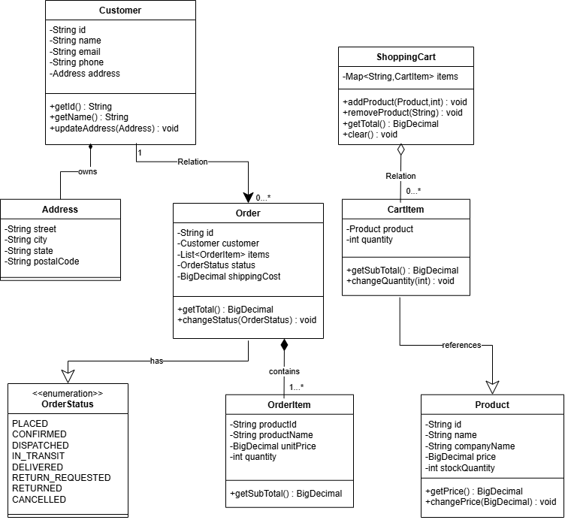

Order State
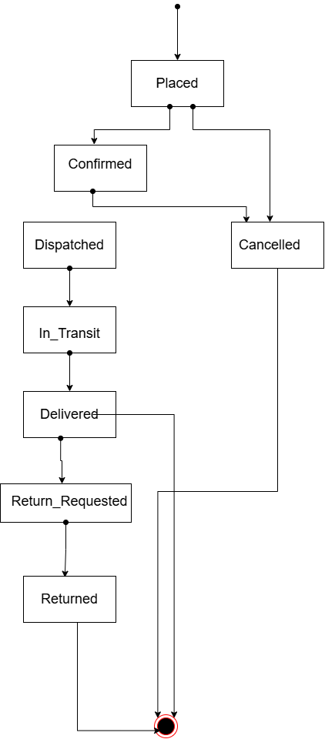
Package Dependency
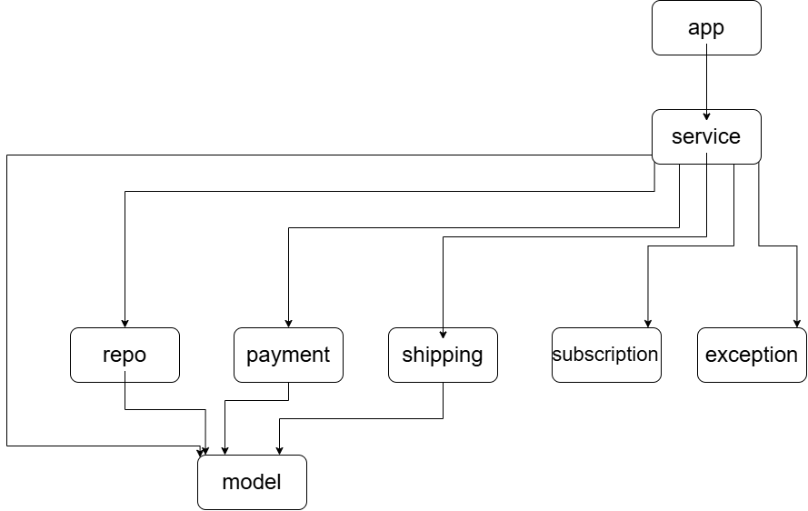

Implementation
01
Domain models and validation
Customer, Address, Product, OrderItem, CartItem, and enums. Use private fields, constructors, validation, and appropriate immutable fields.
Deliverable: valid objects that cannot easily enter invalid states.

02
Repositories and search
Customer and product CRUD operations, email and phone lookup, city filtering, product-name matching, company filtering, exact prices, and price ranges.
Deliverable: testable in-memory data management.

03
Services and authentication
Registration, login, customer lookup, duplicate-email prevention, and admin-only operations.
Deliverable: business rules separate from storage.

04
Shopping cart and checkout
Add and remove items, update quantities, check stock, calculate subtotal, calculate shipping, and generate orders.
Deliverable: end-to-end purchase flow.

05
Order management and tracking
Valid state transitions, admin updates, timestamps, courier information, tracking events, and returns.
Deliverable: a realistic order lifecycle.

06
Payment, subscription, and coupons
Payment polymorphism, gift-card balances, subscription expiry, free shipping, and eligibility-based discounts.
Deliverable: advanced OOP business rules.

Functional Requirements
(implementation w.r.t each functional requirement)
1. Customer Management
- Register new customers.
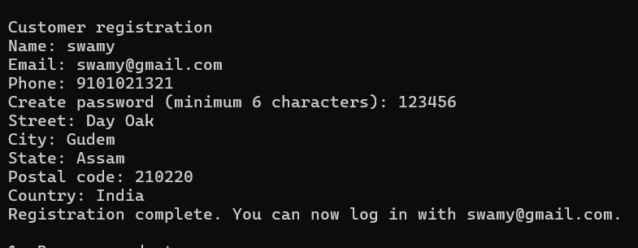
-

View and update customer details.
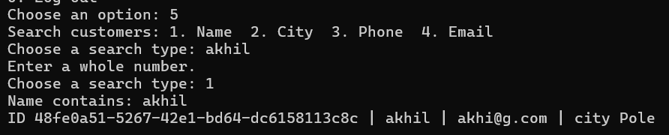
- Delete customer records. 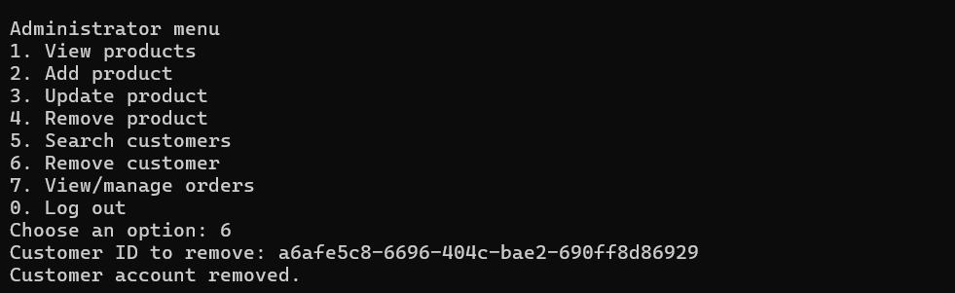
- Search customers by name, city, phone number, or email.
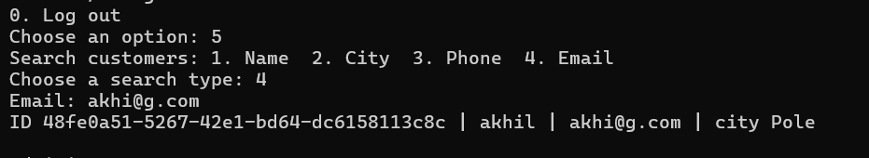

2. Product Management
- Add, update, view, and delete products.
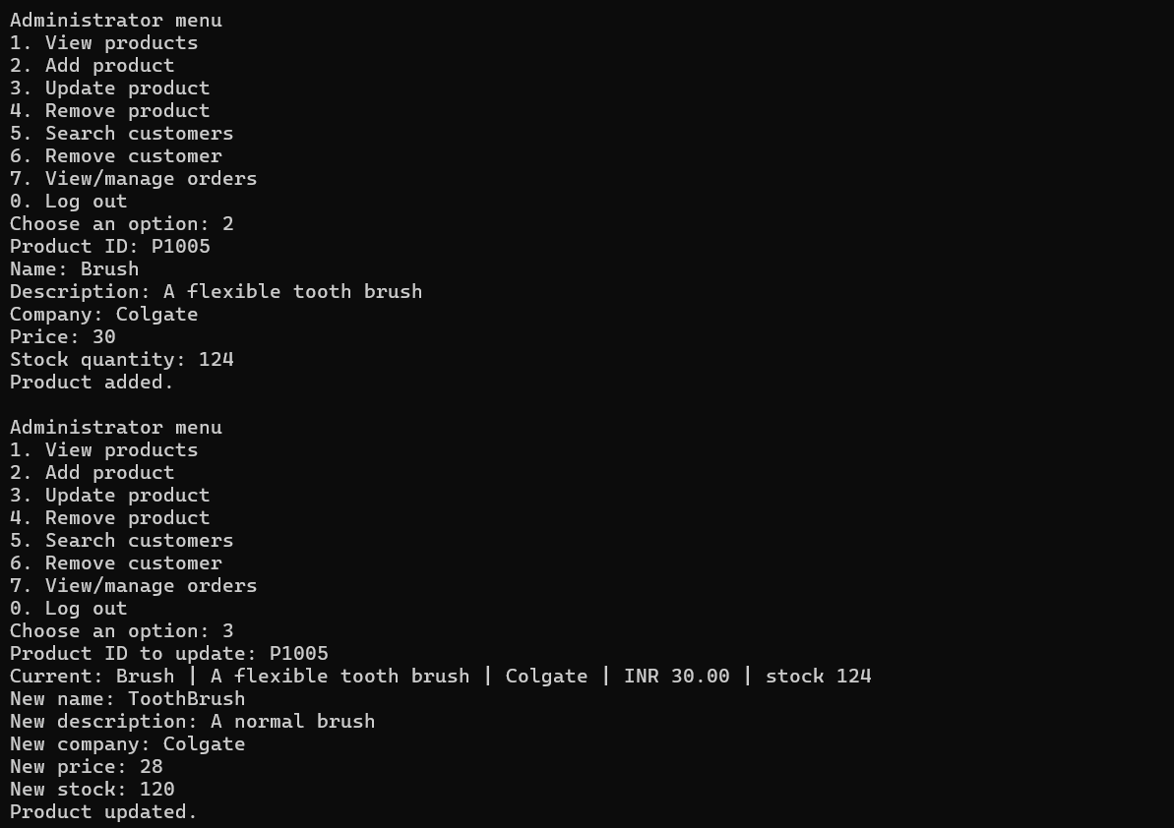
- Search products by product ID or name.
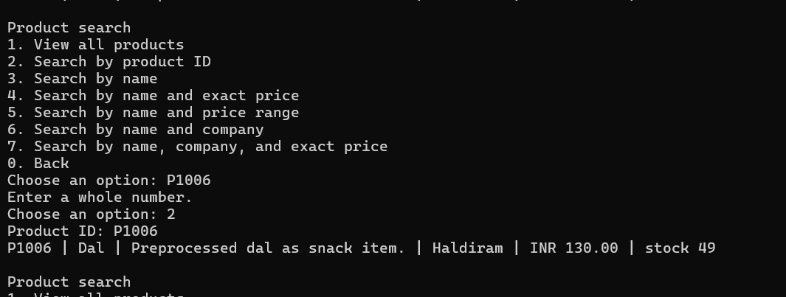
- Filter products by name, price, price range, and company.
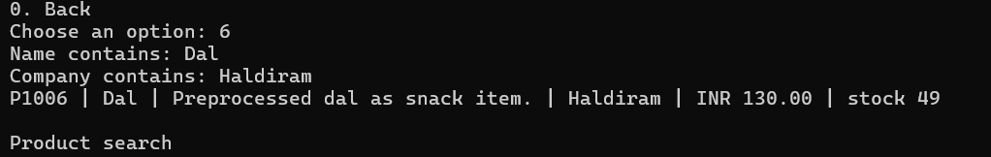
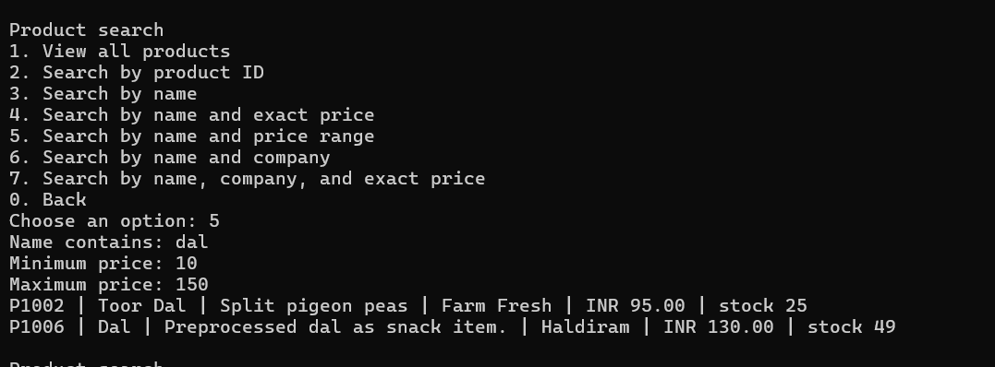
- View product details and available stock.
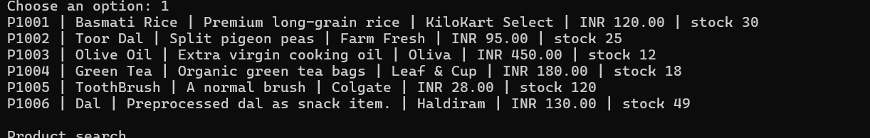
3. Customer Login
- Allow customers to register and log in.
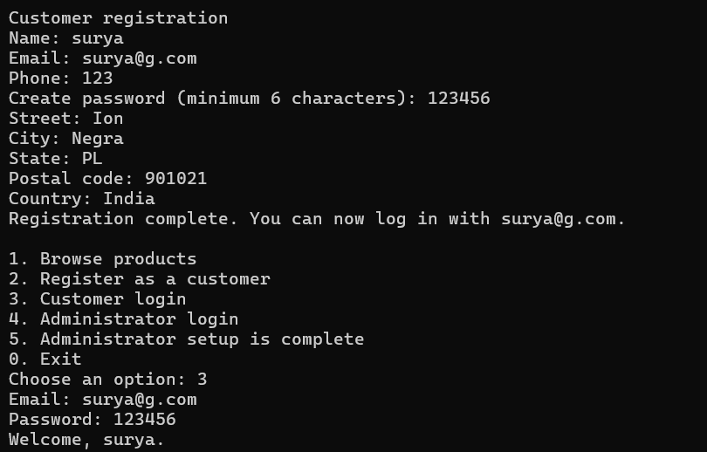
- Allow customers to log out securely.
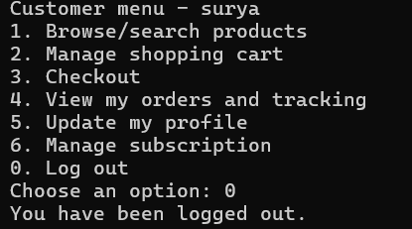
- Restrict shopping and ordering to logged-in customers.
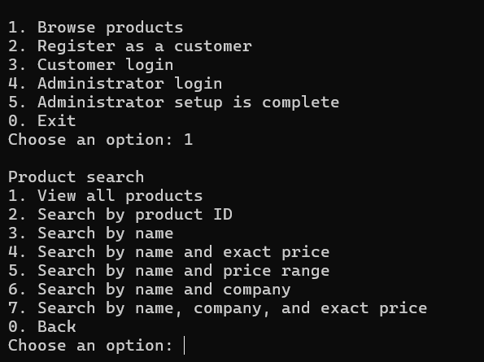

4. Shopping Cart
- Add products to the cart.
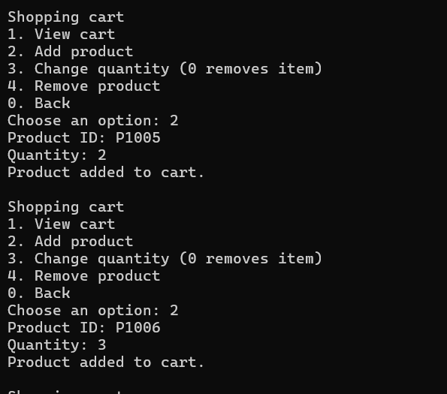

- Update product quantities.
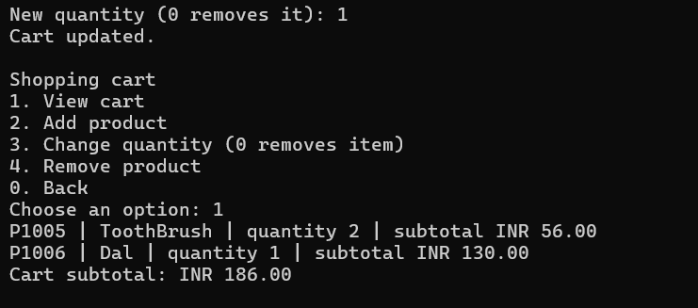
- Remove products from the cart.
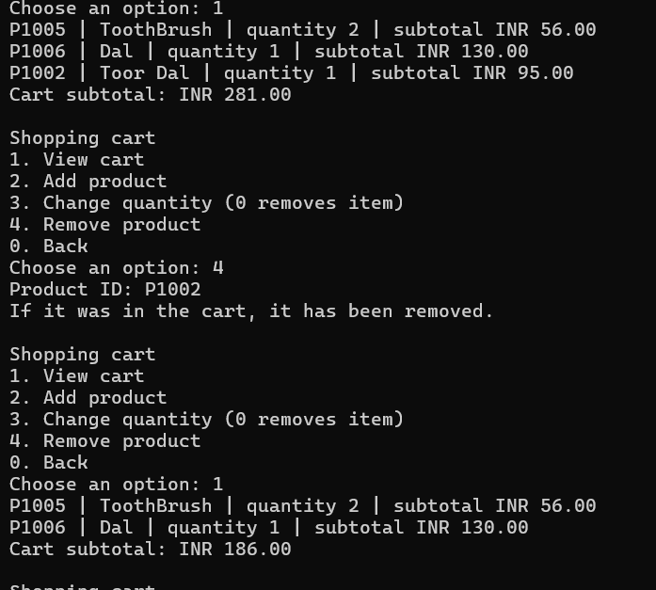
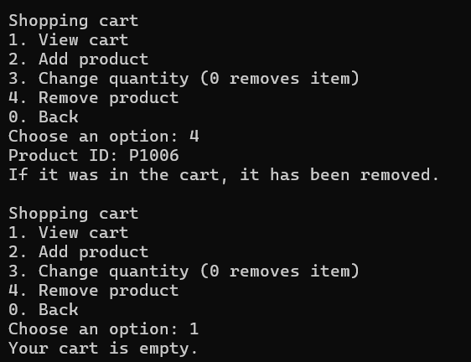

- View cart items and total amount.
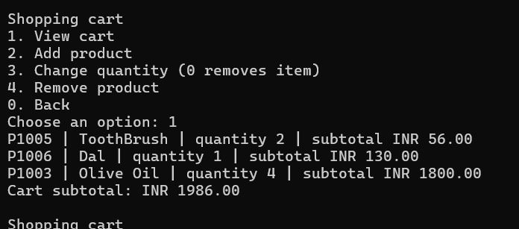

5. Order Management
- Place orders after customer confirmation.
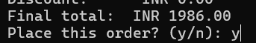

- Store and retrieve customer orders.
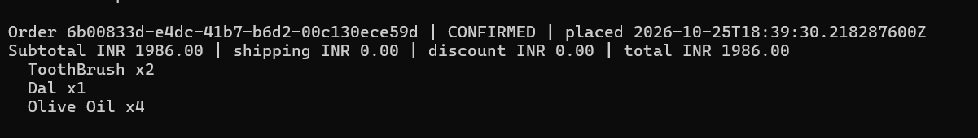
- Calculate product subtotal, shipping cost, discounts, and final amount.
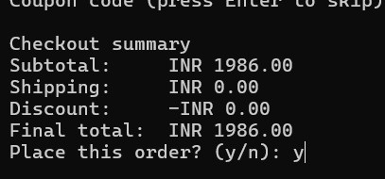

- Update order status.
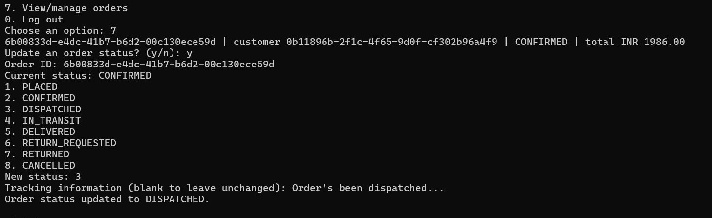

- View order history and tracking details.
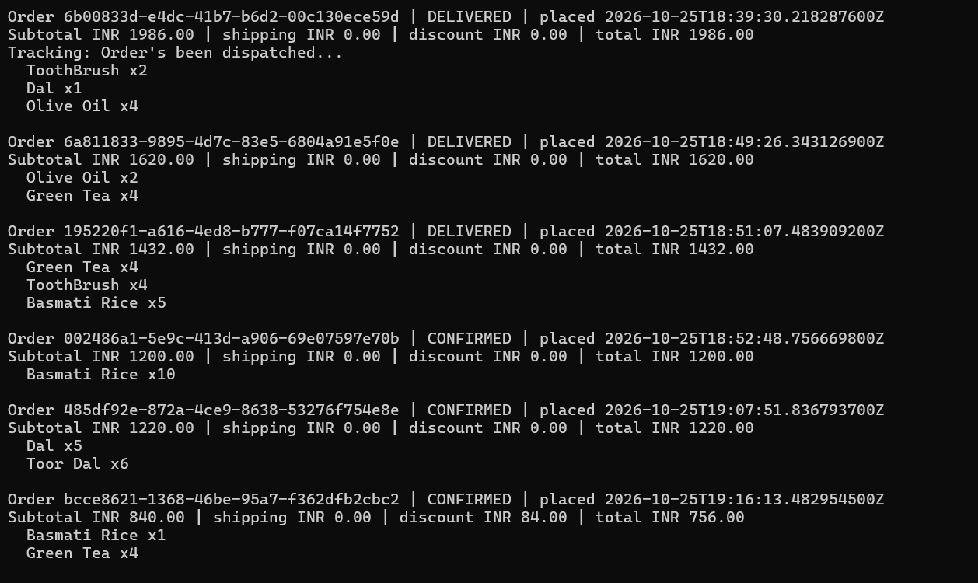

6. Payment Management
- Support UPI payments.
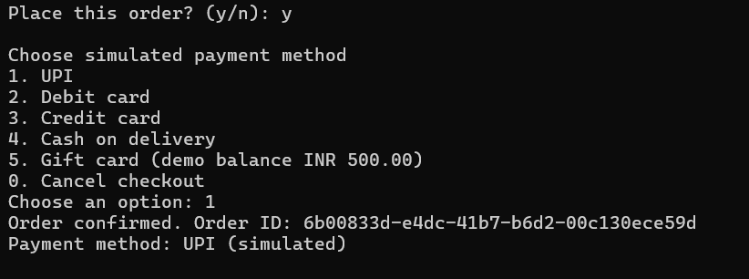

- Support debit and credit card payments.
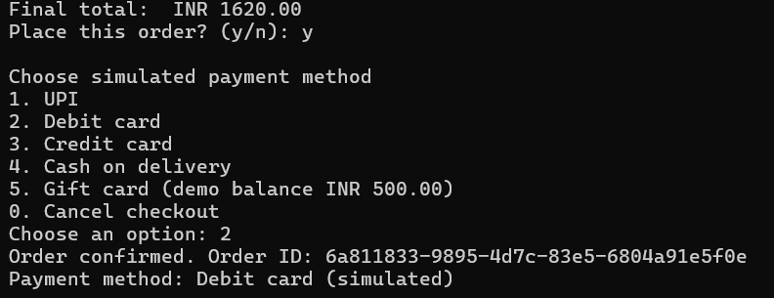

- Support Cash on Delivery (COD).
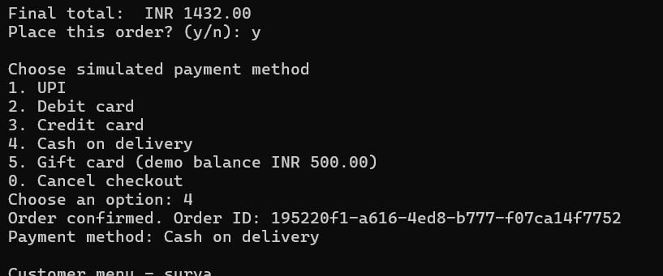
- Support gift card payments.
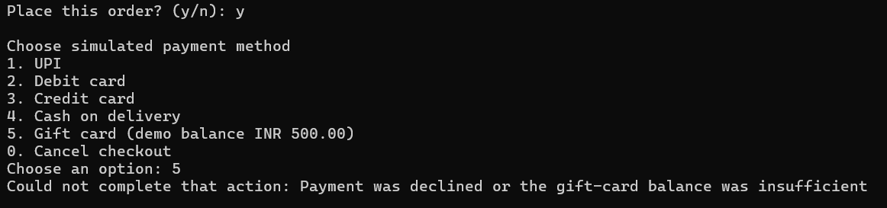

7. Order Tracking
- Track dispatched orders.
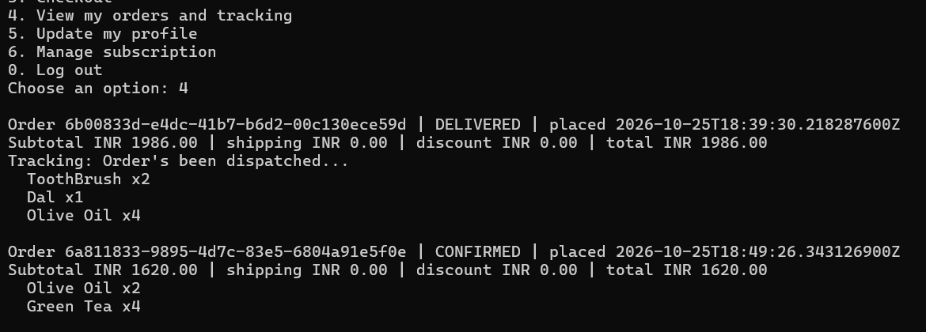

- Display courier and transit status.
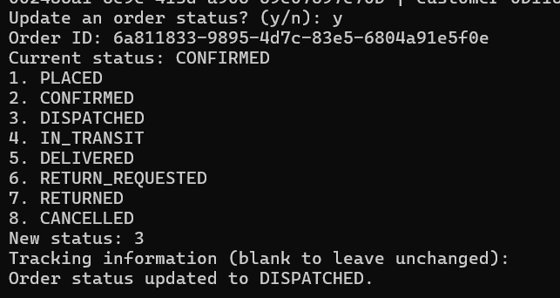
- Update orders as delivered or returned.

8. Subscription Management
- Provide monthly, quarterly, half-yearly, and yearly subscriptions.
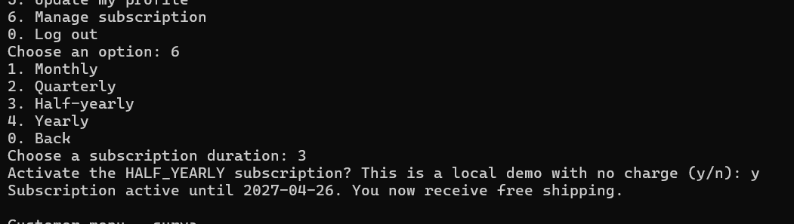
- Offer free shipping to active subscribers.
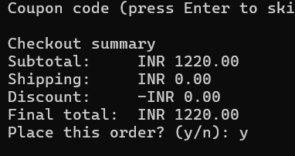

9. Discount Management
- Provide discount coupons based on qualifying order history.
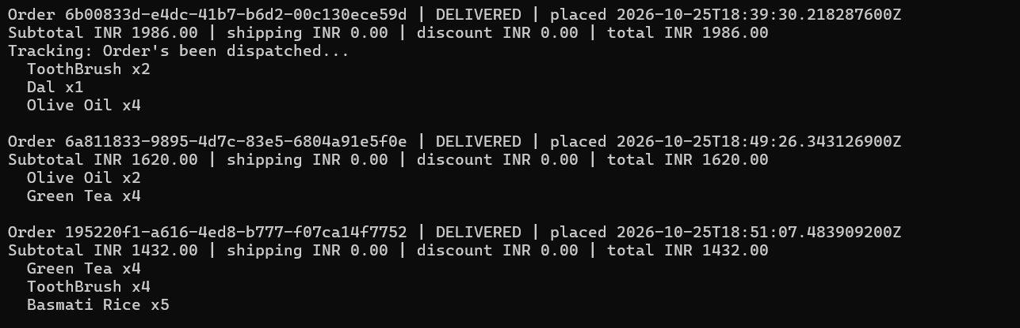
- Check coupon eligibility.
- Apply eligible discounts to orders.
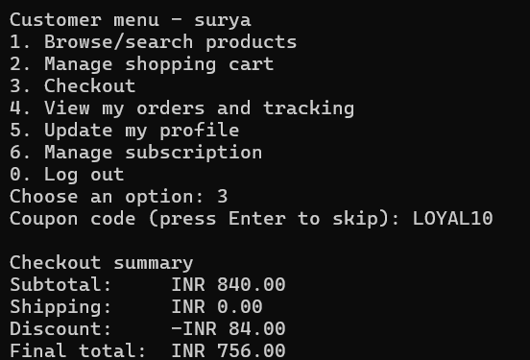

Admin
